Dave Ng’ang’a

#557

Cairn University School of Business

CIS122 Essentials of Networking

Project 2

Project objective:

Testing a fiber optic cable,

Fiber optic has better speed bandwidth and distance.

Equipment used:

|  |  |  |  |  |
| --- | --- | --- | --- | --- |
| Equipment Description | Vendor | Vendor Item #/ ASIN/UPC | Retail price | Actual price (if known) |
| Rasbery Pie 3B+ and case | Amazon - Canacit, iUniker | B07BC6WH7V  B079M96KWZ | 48.99$  10.99$ | unkown |
| Switch with sfp port, layer 3 switch | **NewEgg** | 0XP-003P-00757 | 168.40$ + 10.00$ shipping cost | unknown |
| Fiber optic LC cable and CAT 5e | Fs.com  CableWholesale | SM-LCU-LCU-DX-FS-2M-PVC  846568009525 | 3.20$  0.98$ | Unknown  Uknown |

Detailed list of software and operating platforms used, including version numbers and licensing requirements:

Rasbery OS 3B’s – Used the installed Terminal in order to test connectivity

Network diagram:

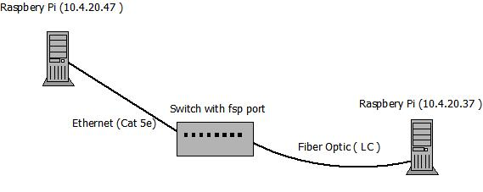

Configurations:

Open a command terminal on the first raspberry pie. (Make sure your raspberry pie is connected to a monitor so you can see what you are doing). Then use the ping command to test the connectivity to the Second Raspberry pie. Connect the fiber optic cable to the switch and the raspberry pie. Then connect the first raspberry pie with Ethernet to the switch. Proceed to ping the second raspberry pie through the first raspberry pie.